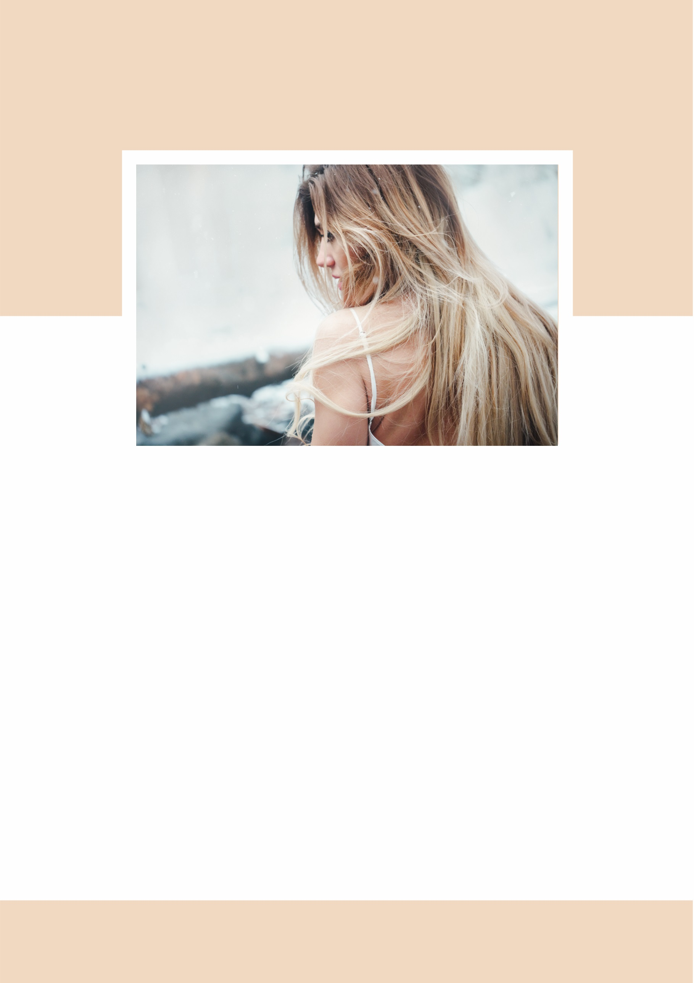
Want Natural-Looking, Sun-Kissed Hair without Going to the Beach?

But Hurry: Only 27 Balayage Packages available, so call (Salon Name) on 0000 0000 NOW!
Address, Suburb

You’ll receive:
Full Head Balayage treatment $165
FREE Tingling Scalp Massage valued at $35.00
FREE Eyebrow Shape and Eyelash Tint valued at $27.00
FREE Hand Massage and Mini-Manicure valued at $51.00
FREE Shampoo and Conditioner to nourish and protect your gorgeous new hair valued at $60.00

Our Iron-Clad Guarantee: we’re so confident in the skills of our stylists that if you’re not happy with your new balayage look, we’ll refund your money in full!

“Working inside in air conditioning all day made my hair look limp and lifeless, but now my hair really does look like its been kissed by the sun! Thanks (Salon Name)! Samantha, Bookkeeper, Albany
SPECIAL OFFER: For just $165, book in for a balayage session at (Salon Name) and receive $173 of bonuses absolutely FREE!

Let’s face it; we don’t spend as much time outdoors as we’d like, and as a result our hair can often look dull, lifeless and in much need of some sunrays! But there is a SOLUTION! (Salon Name) is now offering Balayage. What’s balayage, you may ask? Balayage is the one of the hottest hair trends seen on the red carpet this year! Meaning “to sweep” in French, balayage is a technique where hair colour is hand-painted onto the hair to create a natural, sun-bleached effect. It will transform your lifeless locks into hair that’s vibrant, sexy and simply va va voom!

