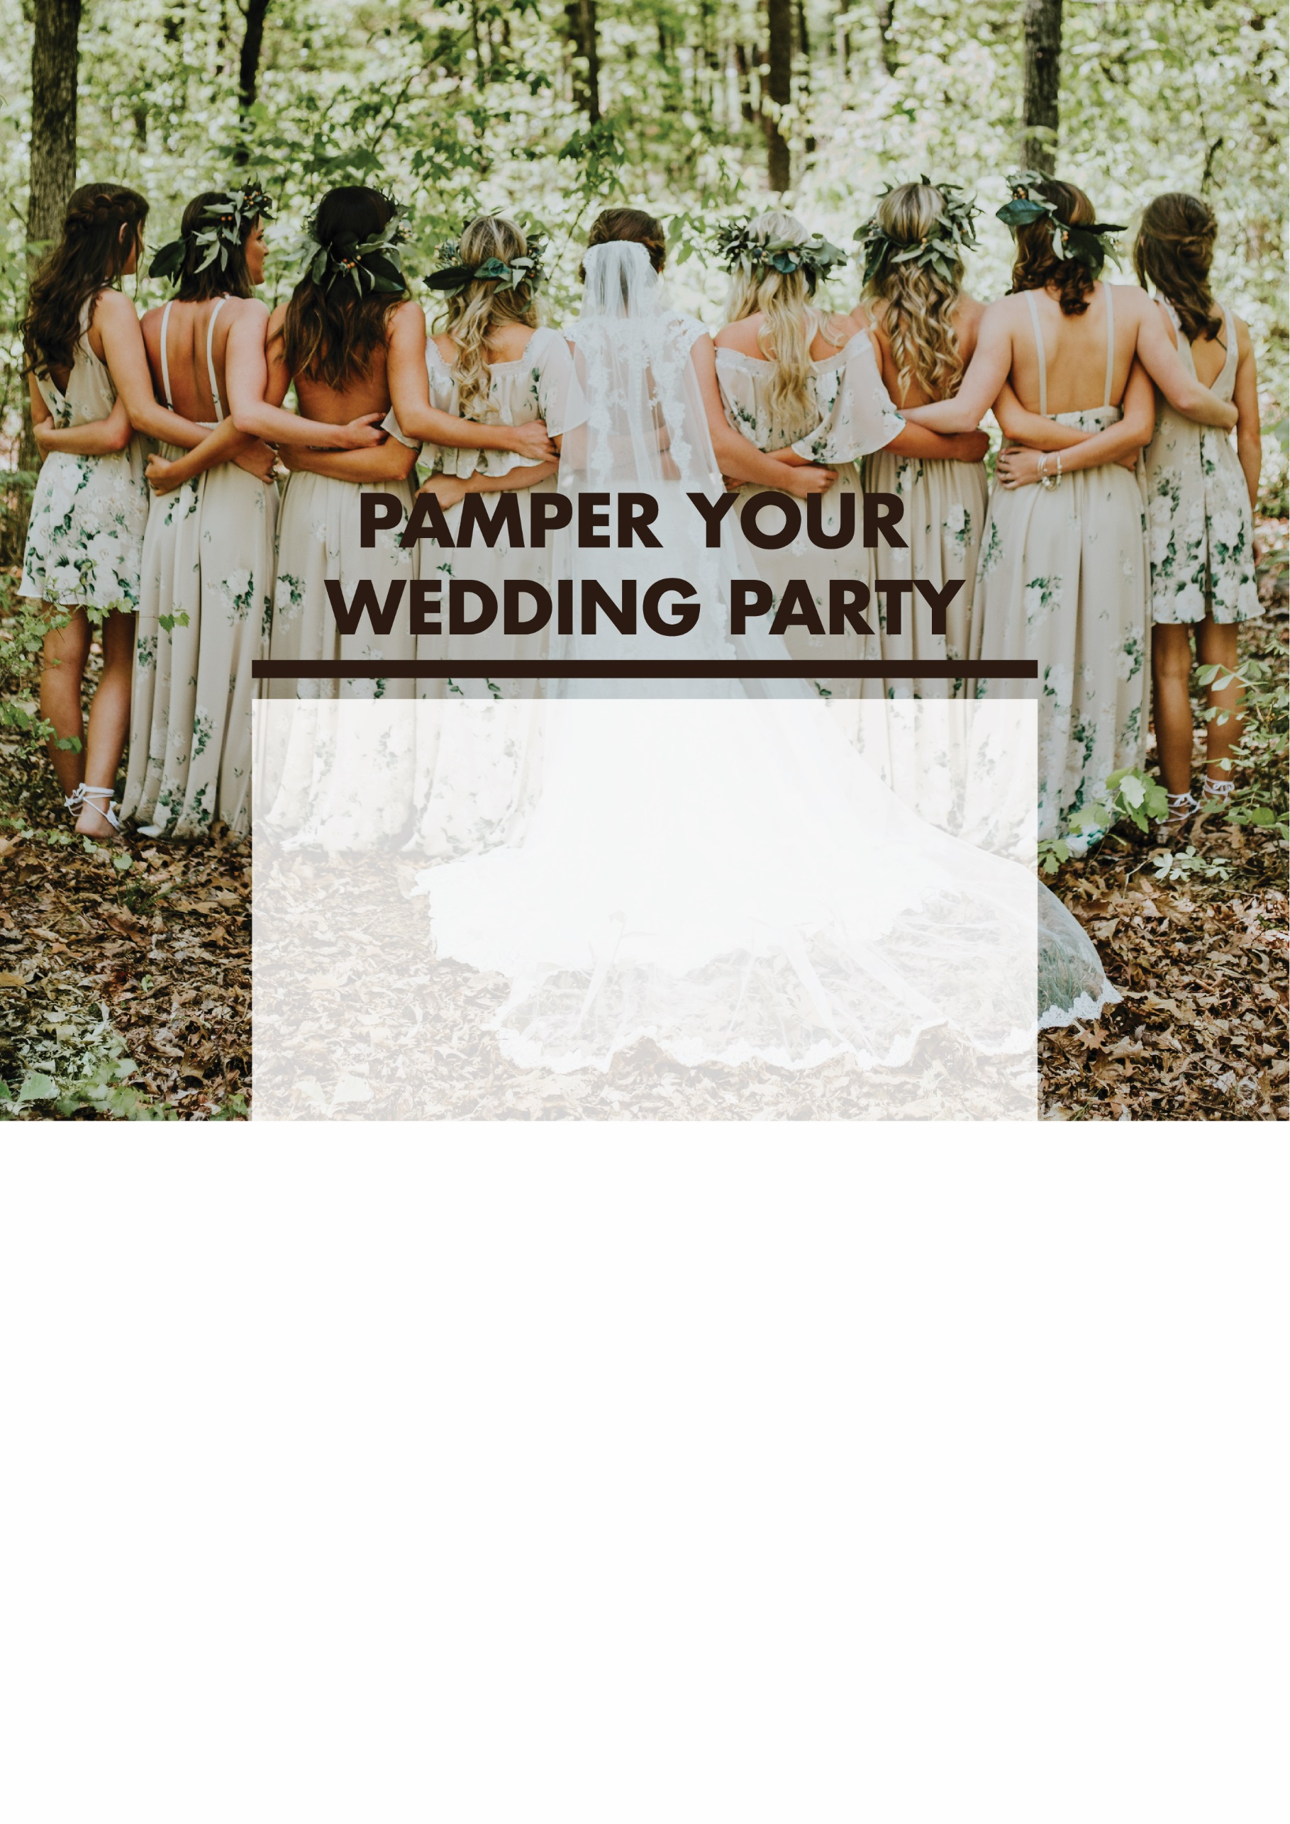

(Salon name) is offering an exclusive wedding package, where you’ll receive the following treatments
for just $339 each!

- Professional style cut with a senior stylist valued at $122 each
- Colour valued at $156 each
- Moisturising hair masque valued at $34 each
- Relaxing 10 minute scalp
massage valued at $23 each
- Blow dry and up-style, valued at $180 each

That’s a total of $515 of value each for only $339 per person!

But HURRY! This offer is limited to the first 29 brides!
Call (Salon Name) on 0000 0000 NOW

  - Our guarantee: If you don’t leave our salon feeling picture perfect, we’ll refund your money in full!
“I LOVE this idea! I’ve been a client of (salon name) for 3 years, and I have this booked for my wedding in December!” – Cindy, PA, Mount Pleasant

