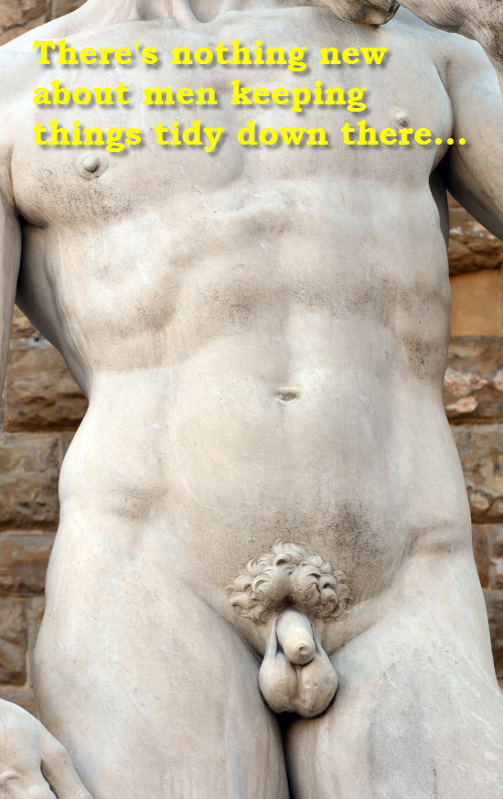
For men who like smooth women.
Guess what. It works both ways.
The ancient Greeks appreciated a certain smoothness in both women and men. So did the great sculptors. Today, many women still go to great lengths for that 'well-groomed' look.
Tonight, how about reciprocating - and surprise your loved one with a new 'do'?
You just never know where it might lead.
GET OUR ONE-TIME SUPER-SPECIAL MAN WAX OFFER NOW
Offer details in here.

Strictly limited to the first X to call
Name of Salon here
Address

PS: Don't even think about asking for a 'happy ending'. You can save that for when you get home.

