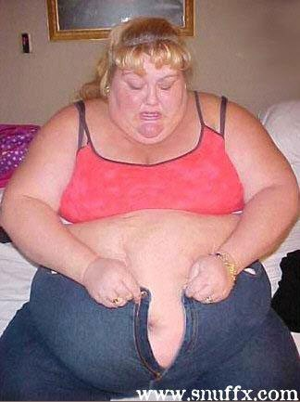
HAVING TROUBLE GETTING YOUR CLOTHES TO FIT? Here Is The Simple Solution...

PLUS Why You’ll LOVE Our Outrageous Guarantee...
“If you aren’t totally delighted with your results, and don’t keep off a minimum of 15 centimetres for 30 days, we will re-wrap you for FREE!!”
Have you put your jeans on recently and felt that they are way too SNUG? It’s time that you stopped feeling FAT! It’s true, even the thinnest of women have “fat days” and the best way to combat that fat feeling is by losing a few inches....I know your probably thinking “well YES, but it takes so long and so much effort” well you know what, it takes only 2 hours and NO effort at all and that’s just the start of it. You will feel so sexy, slim and energised after this PLUS your husband won’t be able to keep his hands off you!.....So what is this amazing treatment called....It’s The Universal Contour Body Wrap and we guarantee it will work! How? Well did you read the guarantee up the top.. we couldn’t guarantee that if the wrap was just water loss could we..NO! Well all you need to worry about is that when you come in for your wrap we will guarantee that you will lose a minimum of 15 centimetres AND we guarantee that you will keep at least 15 centimetres off for a minimum of 30 days or we will re-wrap you for FREE! I thought that you would want some proof so I have included some before and after pictures on the back and a couple of testimonials for you to see.
- Feel Sexier Instantly
- Lose Unwanted Inches – 15cm GUARANTEED! (anything over that is a bonus)
- Detoxify Your Body
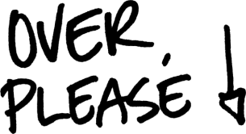
- Tighten Flabby Skin
- Reduce The Appearance Of Stretch Marks
- Re-Shape Your Whole Body

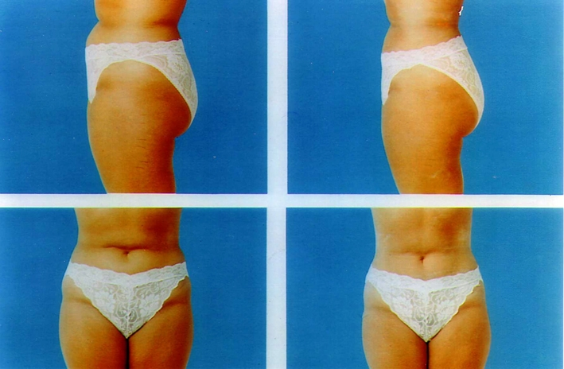
What have you got to lose besides those extra 15 centimetres?

“I was very sceptical about doing a course of wraps but once I finished and I went shopping for clothes and found that I was now a size 10 (from a 12) I was over the moon” Tanya Long Bunbury
“I had a similar treatment many years ago and I knew that it worked. I only did it for the detoxification benefits that it gave my body..the fact that i was skinner was a bonus” Sue Mark Australind
‘Wrap Me Slim’
Massive Value of $264 and you pay only $143
- 1 Universal Contour Body Wrap lose a minimum of 15cm and feel amazing! – Valued at $170
- Vibration Plate Session improves circulation and helps speed up your metabolism – Valued at $45
- Body Shape Analysis clarifies which one of Dr Sandra Cabot’s Body Shapes you are – Valued at $35
- Before and After Measurements to find out how many centimetres you have lost – Valued at $15
- Cleansing Tea keep the cleansing happening at home with your very own cleansing tea – Valued $6
- Jealous friends who don’t look or feel as good as you do – PRICELESS!
“Ultimate Slimmer Wrap Package”
Get everything above PLUS an extra 3 wraps to get you looking your absolute best......psst did you know that we have had ladies lose anywhere from 37cm to 76cm with a package of wraps!
You pay ONLY $410 for $781 worth of treatments – you save $371!
WARNING: Be quick, due to high demand there are only 19 Wrap Me Slim Packages available, so pick up the phone and book yours NOW

