FREE for Kids!

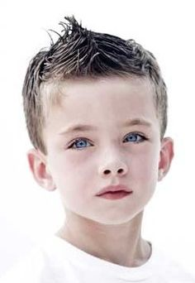

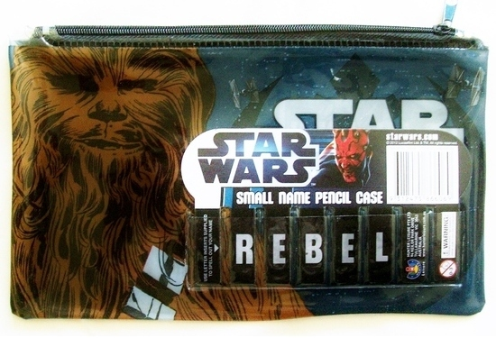
Get Your Little One Looking SHARP for School - and get a FREE Star Wars Pencil Case with every Kid's Cool Cut at ABC Salon!
Call NOW 000 000 000
Your Salon Details, Map Etc
But be QUICK!
First 25 kids ONLY

