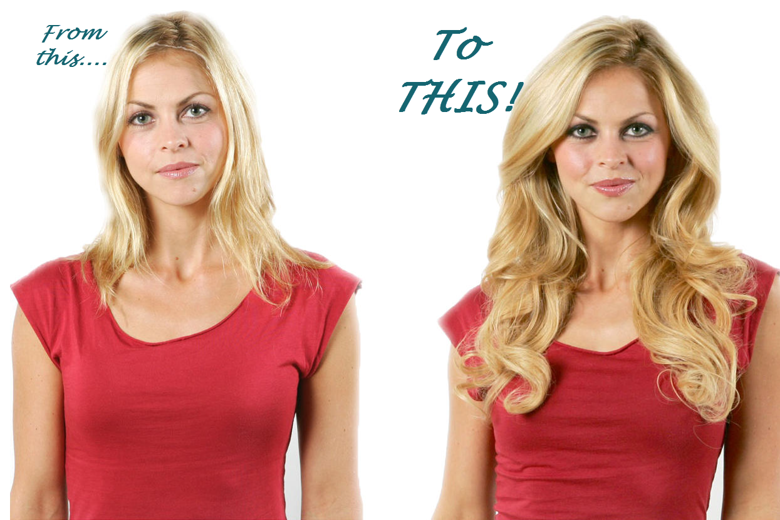
Flawless Extensions logo 9271 3317 or
Call NOW!
But, a WARNING….You WILL literally stop traffic!
INSTANT Long Hair!
SPECIAL OFFER - FIRST 27 APPOINTMENTS ONLY
Haven't you sometimes wished you could flaunt long, luscious hair that literally turns heads? Well, now you can, instantly, with hair extensions that are indistinguishable from your own hair. In just 90 minutes with our specialist hair extensionist Krystal you'll walk out of Vintage Hairess with locks so long and amazingly flawless your friends will be blown away - or it's free. In fact, that's our Guarantee: "If your friends don't gasp and swoon over your new hair, you pay nothing!" But this special introductory offer can't last. So ACT FAST!
offer in here
pic of Krystal with caption

