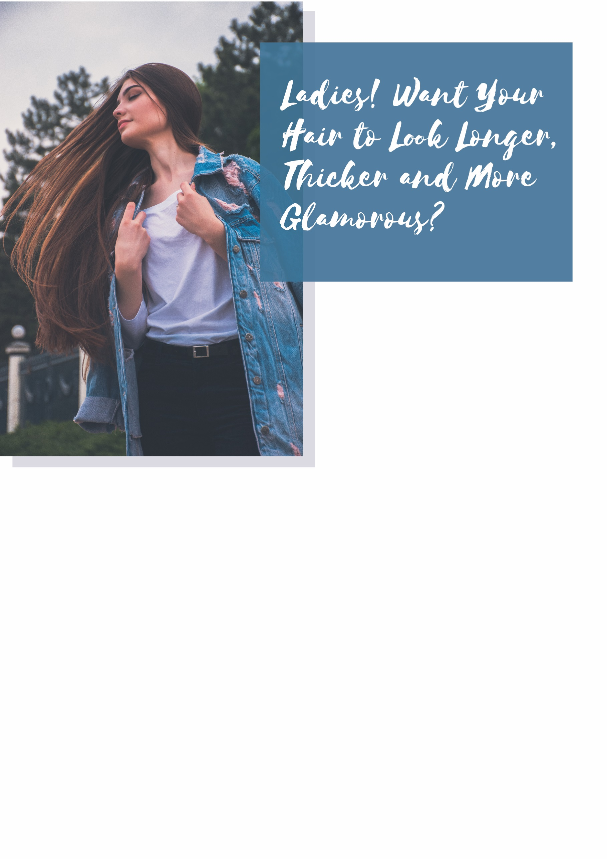
Testimonial: I was so sick of my thin, straggly hair – it was embarrassing and unattractive! But after getting hair extensions at (Salon Name) my hair is now thick, voluminous and I feel so sexy!
Courtney, Business Graduate, Mt Lawley

BUT HURRY! Only 27 of these packages available; if they sell out, you miss out! So call (Salon Name) on 0000 000 NOW!
Salon Address, Suburb

We offer all our clients an outrageous 100% money-back guarantee: If you’re not completely satisfied, we’ll refund your money IN FULL!

That’s $528 of value for just $357!
You save $171!

For just $357 you’ll receive:
Full Set Hair Extensions valued at $347
FREE Relaxing Scalp Massage valued at $35
FREE Eyebrow Wax and Tint valued at $49
FREE Express Manicure valued at $37
FREE 2 Styling Products valued at $60

Get the glam look at (Salon Name) with our special offer and experience the luxury of longer, fuller hair today! Our expert stylists will apply your extensions with precision and care, ensuring your new gorgeous hairdo is done to absolute perfection. Having hair extensions means your you can look better without spending so much time on styling and waiting for your hair to grow! Your hair will look longer, shinier and more voluminous after a single extension session!

Hair extensions have proved popular the world over – even A-list celebrities like Jennifer Lopez, Megan Gale and Beyoncé Knowles use them regularly! They instantly boost the look of your natural hair to be longer, thicker and sexier than ever before!

