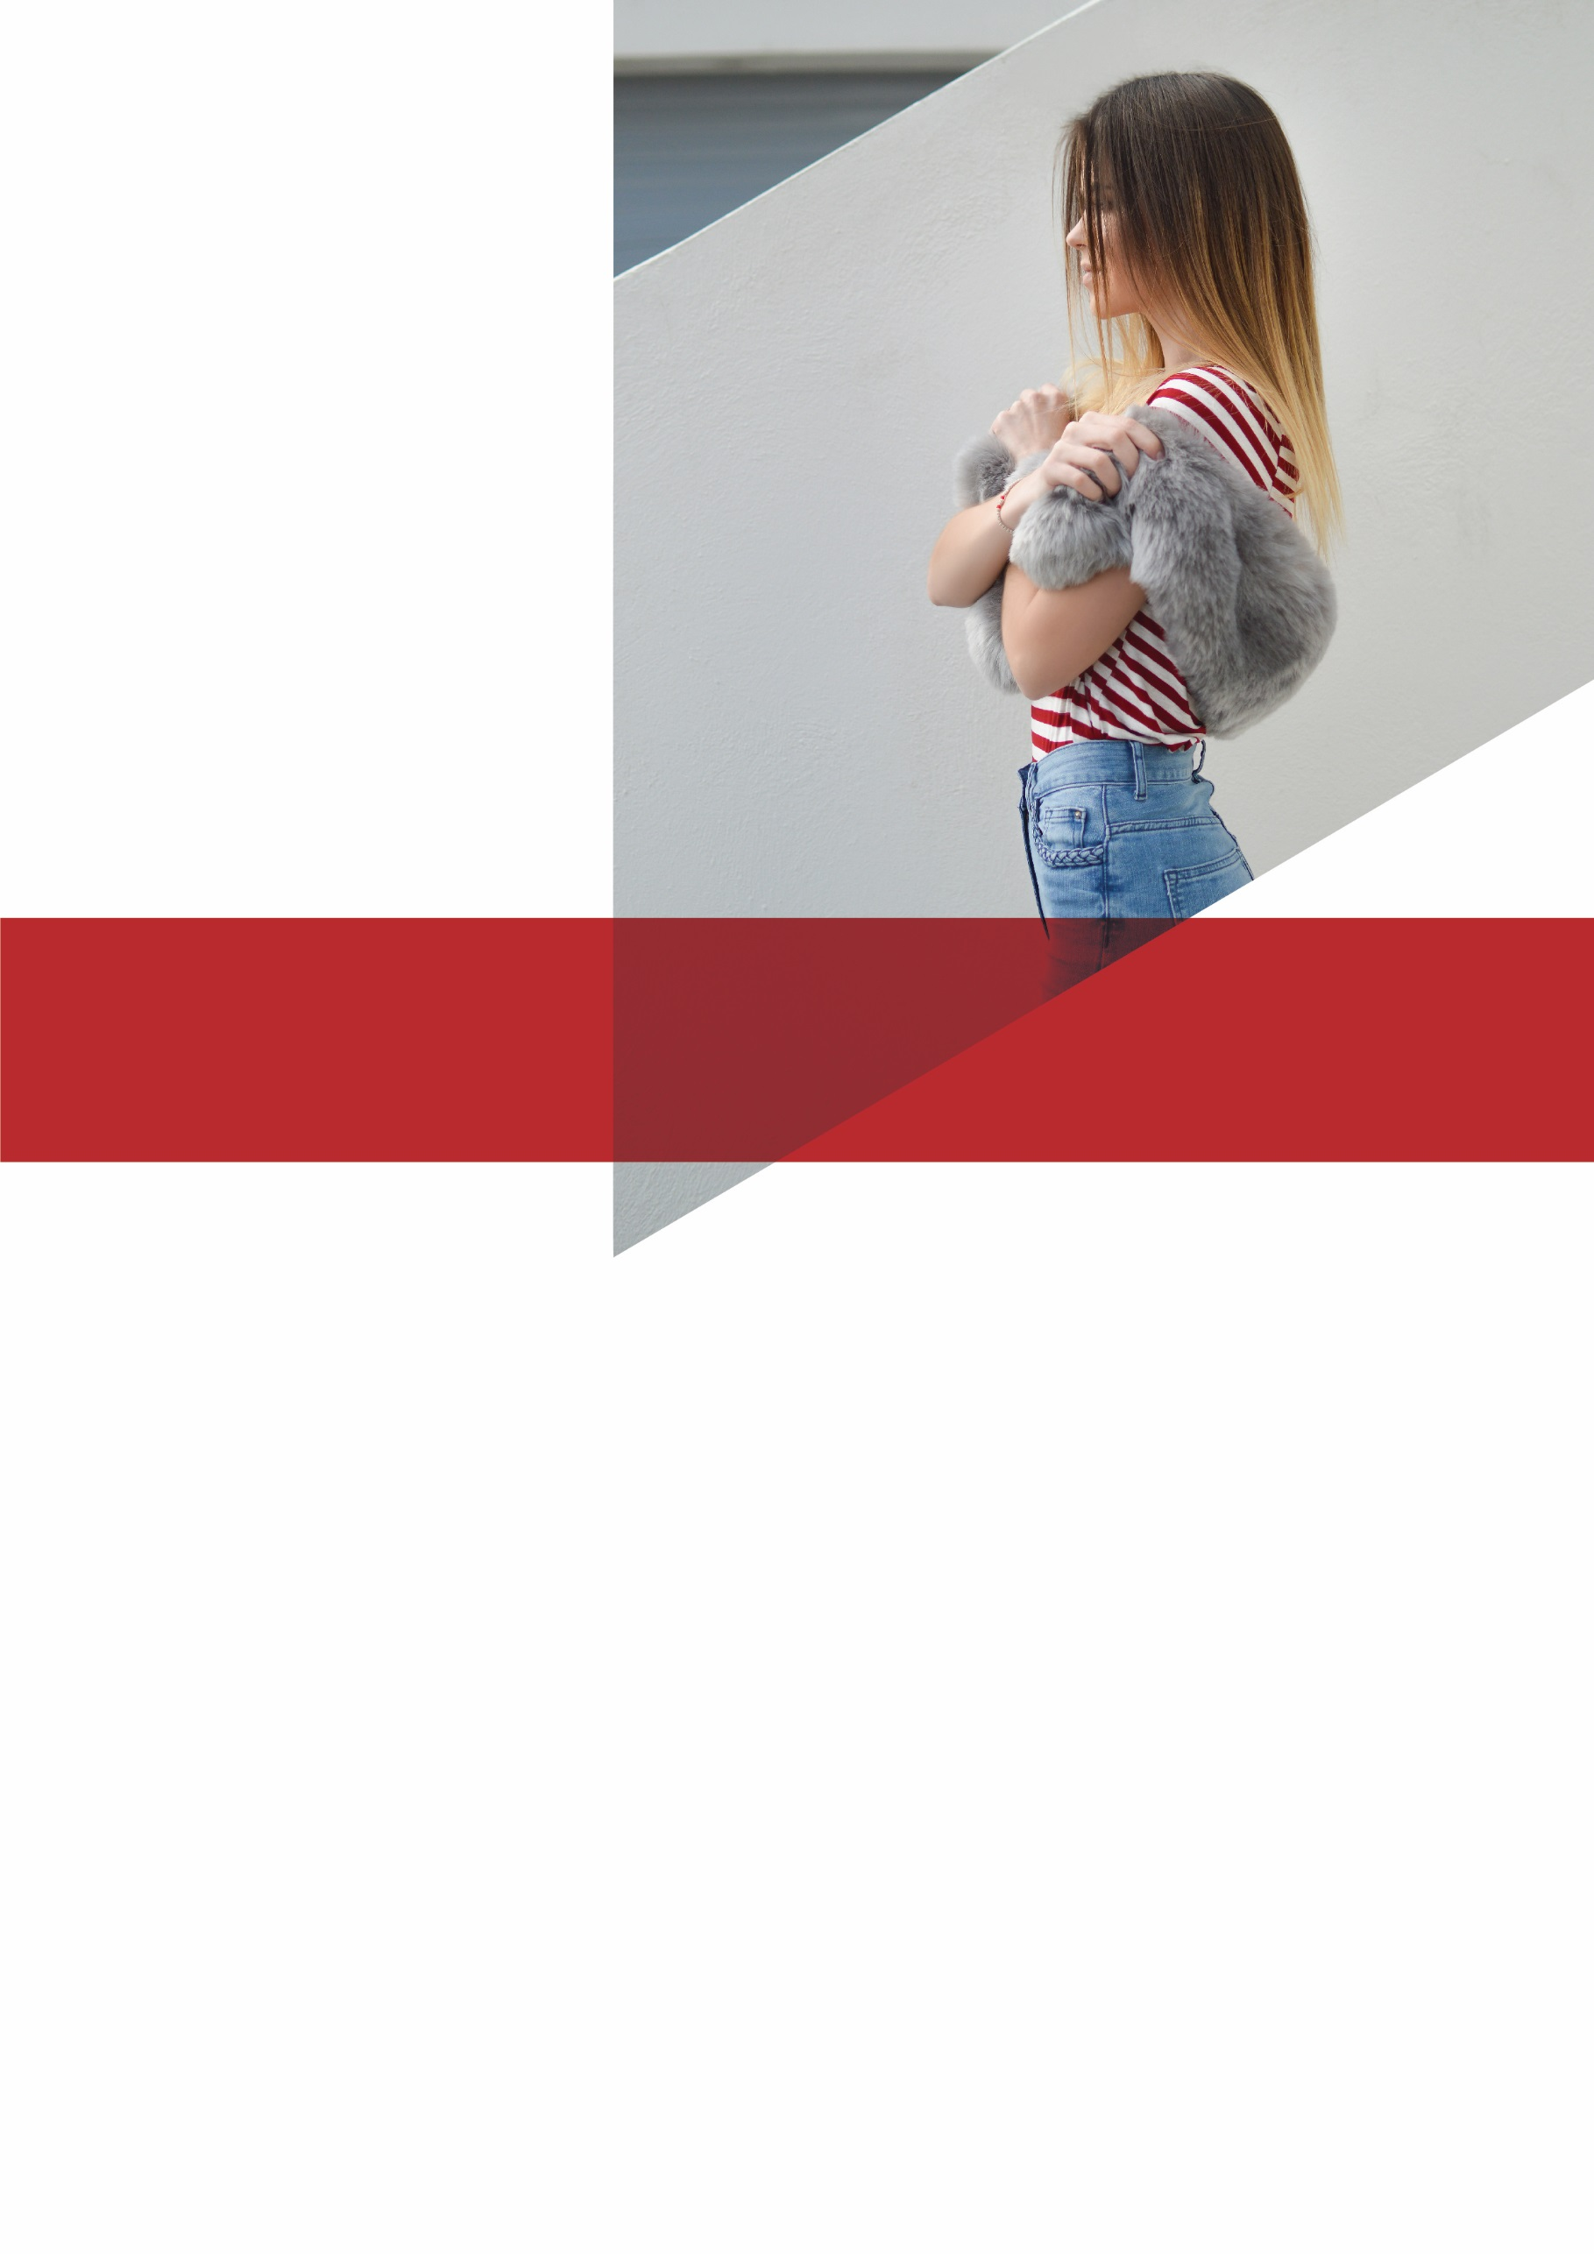
Is Managing Your Frizzy
Hair a Constant Battle?

Salon Name, Address, Suburb
Our Guarantee: If don’t leave our salon feeling completely satisfied with your gorgeous new hair, we’ll refund your money in full!

Testimonial:
“I love my new hair! It’s so easy – I wake up, brush it and its perfect! No more wasted time or expensive products…just perfect, fuss-free hair, every day!”
Tamara, Barista, Mt Clarence

But HURRY! Only 37 packages available,
so call (Salon Name) on 0000 0000 NOW!!
That’s an unbelievable $573 of value
for just $399!

You’ll receive:
Chemical hair straightening treatment $399
FREE Tingling Scalp Massage valued at $35.00
FREE Eyebrow Shape and Eyelash Tint valued at $27.00
FREE Hand Massage and Mini-Manicure valued at $51.00
FREE Shampoo and Conditioner to nourish and protect your gorgeous new hair valued at $60.00

Ladies, we know how hard it is to keep our hair looking superstar-gorgeous, and it’s even more difficult for those of us who have naturally curly or frizzy hair.
But there is a PERMANENT solution! Book in now at (Salon Name) for a Chemical Straightening Treatment session and get the smooth, glamorous locks you’ve always wanted, EVERY DAY!

SPECIAL OFFER: For just $399, get your hair chemically straightened at (Salon Name) and receive $173 of bonuses absolutely FREE!

