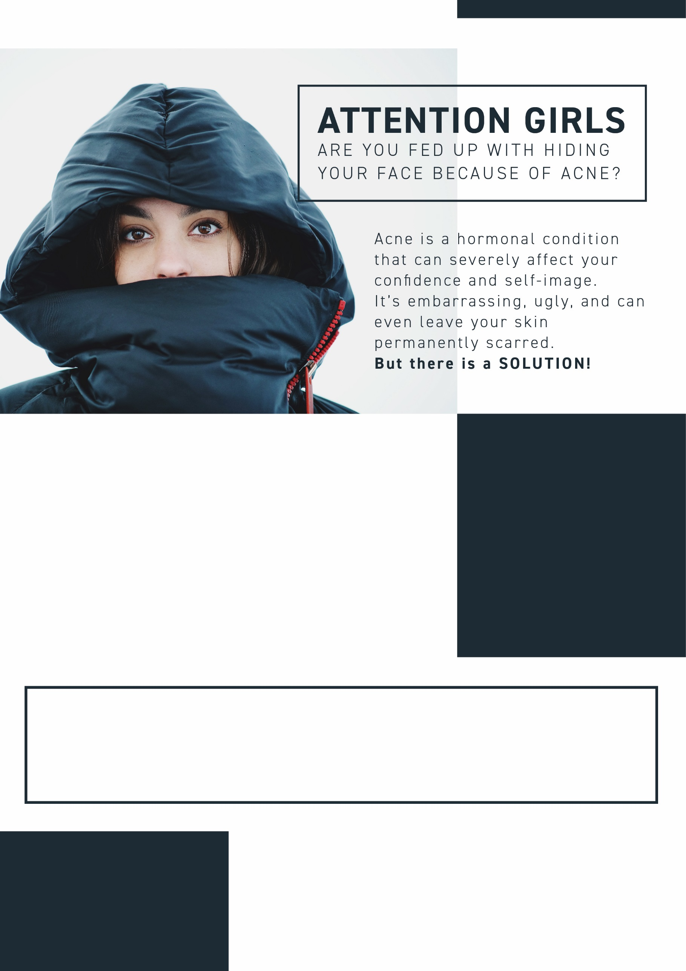
Salon Name, Address,
Suburb

Testimonial:
“Having acne made me feel unattractive and self-conscious – I dreaded going out in public and it was affecting my studies. But after having IPL at (Salon Name), my skin has improved dramatically and I feel happier and more confident!”
Tamara, Arts Student, St Albans.
(Salon Name) is offering IPL (Intense Pulse Light) treatment. IPL is an effective way of destroying the bacteria that causes acne and also helps to reduce the appearance of scars.
For just $500, we’re offering an EXCLUSIVE IPL package deal, giving you the opportunity say bye-bye to bad acne and hello to gorgeous skin TODAY!

But HURRY! This offer is only available to the first 17 callers,
so phone (Salon Name) on 0000 0000 to book NOW!
SPECIAL OFFER:
For just $500, book in for 4 IPL Skin-Clearing sessions and get the 5th session FREE! You save $125!
PLUS: Be one of the first 10 callers to book and receive a FREE skin care product worth $27!

