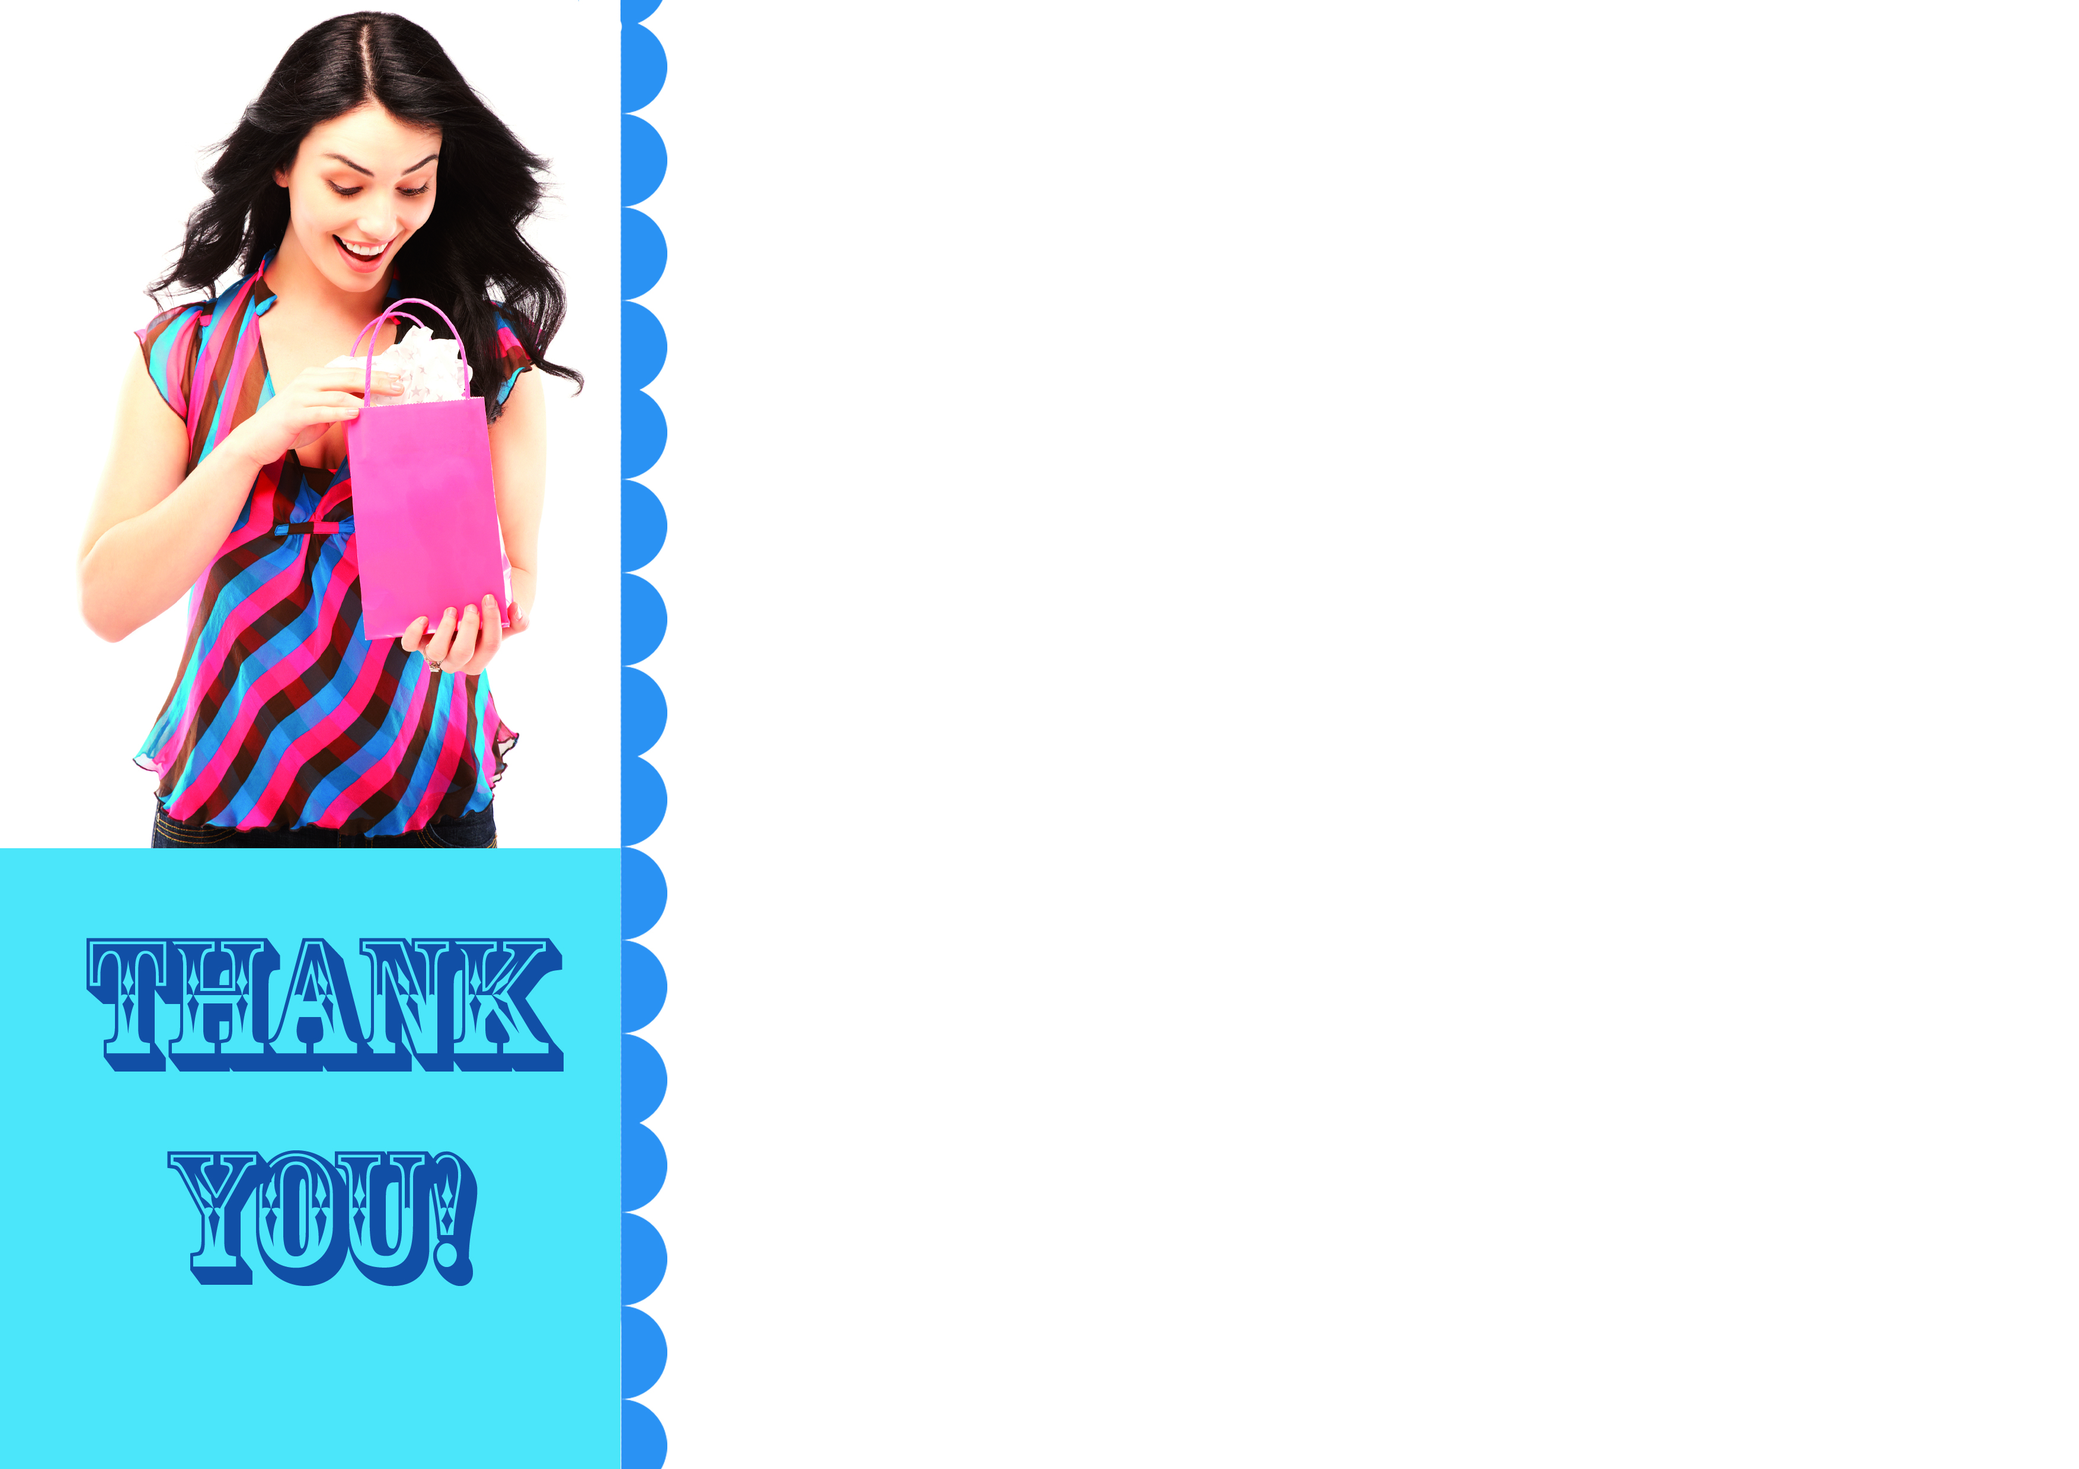
Please accept these $20 Gift Vouchers for You and a Friend as a Token of Our Appreciation from (Salon Name)

Dear (Client’s Name)
It was lovely to see you here at (Salon Name).
We love meeting new people, and we certainly appreciate the trouble you took to come in and see us.
So, as a small token of our appreciation, we’ve enclosed a gift voucher for you to the value of $20, and another one for you to give to a friend, family member or work colleague.
These vouchers are valid for the next 21 days for any treatment here at (Salon Name), and we’d love to see you again in the near future.
When you want to redeem the voucher, please just call (Salon Name) on 0000 0000 and speak to Tamara or Renee.
All the best and we look forward to seeing you again.
Warmly,
(Your name here).
PS: Our Guarantee – If you’re not completely delighted with our service or your treatment, just say so and your entire fee will be refunded, no questions asked!

Phone NOW on 0000 0000 to book your appointment! Salon Name, Address, Suburb
$20.00 Special New Client Voucher - NO EXPIRY DATE!
Especially for:
Authorised by:
Date:

This voucher entitles you to $20 off any service at our salon.

