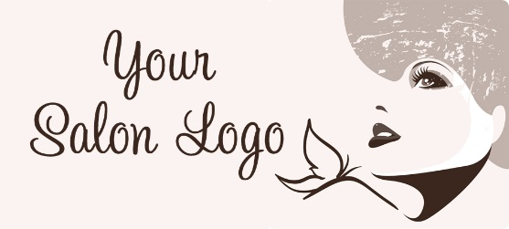
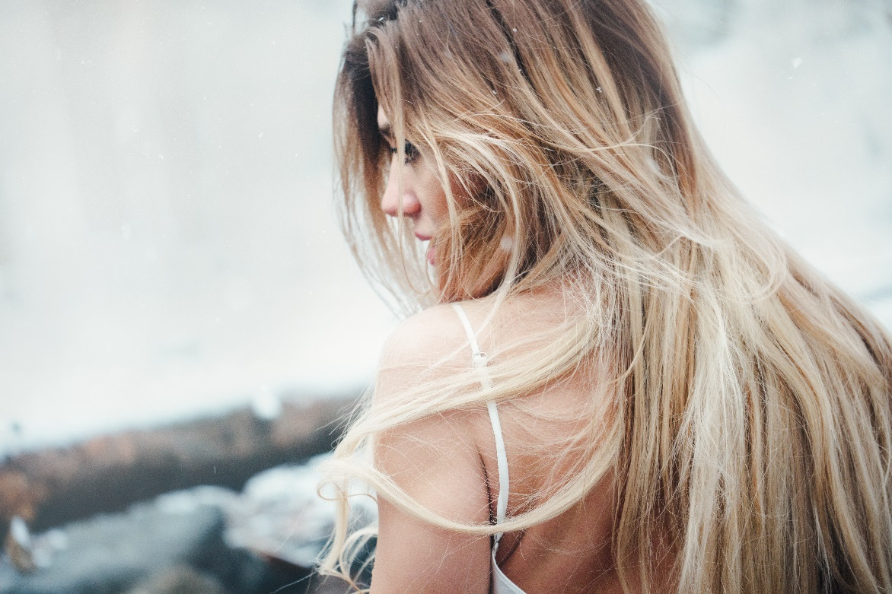
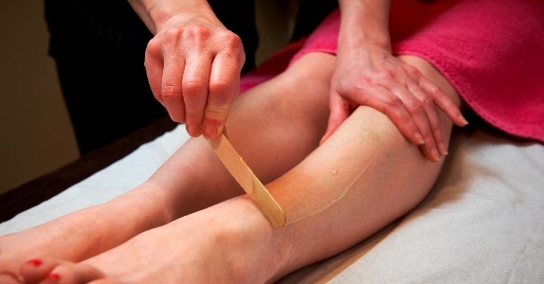

Lorem ipsum dolor sit amet, consectetur adipiscing elit. Aliquam tellus erat, ultrices vitae odio sed, porttitor vulputate dui. Suspendisse elementum diam rutrum dolor volutpat, ut rutrum eros tristique. Donec eget iaculis tellus, nec lobortis ligula. In non nibh nisl. Proin porta non leo at dictum. Quisque purus nibh, dapibus id suscipit in, fermentum eu mauris. Nullam id neque efficitur, sodales justo quis, iaculis nibh. Quisque nec lacus libero. Pellentesque vestibulum nunc lacus, eget vulputate nisi mollis et. In hac habitasse platea dictumst.

Vivamus at pharetra dolor, condimentum suscipit ligula. Praesent quis augue eu arcu molestie ullamcorper. In id maximus lorem. Proin semper mollis lobortis. Maecenas commodo varius enim, a facilisis leo dignissim nec. Donec eu sollicitudin neque. Maecenas rhoncus lorem augue, nec scelerisque nisl efficitur id. Aenean commodo massa vel dui cursus gravida. Vivamus faucibus ornare nulla, eu consequat ante laoreet at.

Welcome to the (salon name) newsletter. This month, we want to talk about anti-ageing treatments. Anti aging doesn't have to mean turning to facial cosmetic surgery or harsh skin rejuvenation treatments. Increasingly there's a trend to focus on anti aging beauty from within.

$99

Save $50

Book Now!
Call 000 000 000

Special Offer Can Be Placed Here
Thanks for supporting (salon name). if you have any questions or issues about any treatments, do call us at 9999 9999, or email us at info@beautysalon.com.au. we would love to hear from you!
Lorem ipsum dolor sit amet, consectetur adipiscing elit. Aliquam tellus erat, ultrices vitae odio sed, porttitor vulputate dui. Suspendisse elementum diam rutrum dolor volutpat, ut rutrum eros tristique. Donec eget iaculis tellus, nec lobortis ligula. In non nibh nisl. Proin porta non leo at dictum. Quisque purus nibh, dapibus id suscipit in, fermentum eu mauris. Nullam id neque efficitur, sodales justo quis, iaculis nibh. Quisque nec lacus libero. Pellentesque vestibulum nunc lacus, eget vulputate nisi mollis et. In hac habitasse platea dictumst.

A NOTE FROM YOUR LOCAL SALON OWNER

^{The} Beauty Newsletter
111 Example Street, Suburb
000 000 000
www.website.com.au

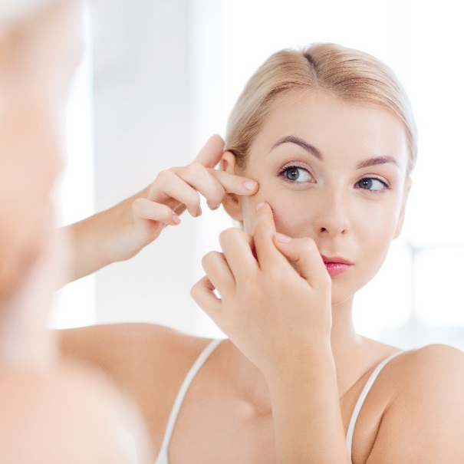

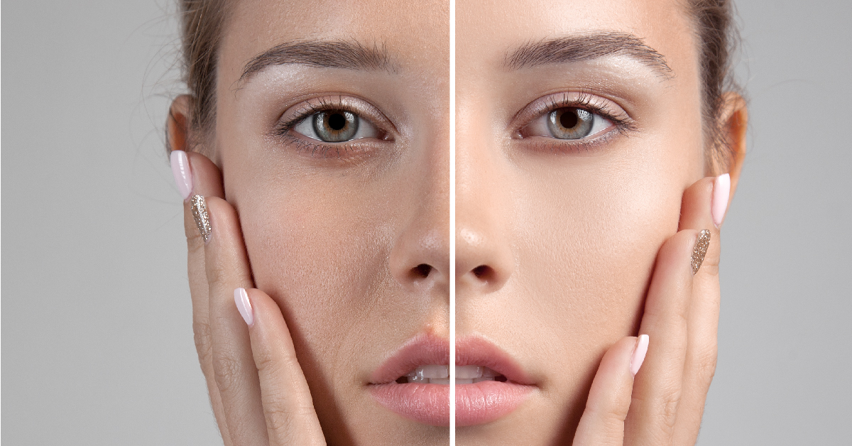

Lorem ipsum dolor sit amet, consectetur adipiscing elit. Aliquam tellus erat, ultrices vitae odio sed, porttitor vulputate dui. Suspendisse elementum diam rutrum dolor volutpat, ut rutrum eros tristique. Donec eget iaculis tellus, nec lobortis ligula. In non nibh nisl. Proin porta non leo at dictum. Quisque purus nibh, dapibus id suscipit in, fermentum eu mauris. Nullam id neque efficitur, sodales justo quis, iaculis nibh. Quisque nec lacus libero. Pellentesque vestibulum nunc lacus, eget vulputate nisi mollis et. In hac habitasse platea dictumst.

Ninety percent of women have cellulite — regardless of shape, size or age. It appears when a collection of fat cells gets trapped in the connective tissue below the skin, causing its surface to pucker.

Salon Name, 000 Address St, Suburb Phone: 000 000 000

Special Offer Only $99 save $50!

Only 27 Packages Available on this Special Price, so Book Now on 9999 9999!

Lorem ipsum dolor sit amet, consectetur adipiscing elit. Aliquam tellus erat, ultrices vitae odio sed, porttitor vulputate dui. Suspendisse elementum diam rutrum dolor volutpat, ut rutrum eros tristique. Donec eget iaculis tellus, nec lobortis ligula. In non nibh nisl. Proin porta non leo at dictum. Quisque purus nibh, dapibus id suscipit in, fermentum eu mauris. Nullam id neque efficitur, sodales justo quis, iaculis nibh. Quisque nec lacus libero. Pellentesque vestibulum nunc lacus, eget vulputate nisi mollis et. In hac habitasse platea dictumst.

Whether you're using waterproof makeup or sunless tanner, "playing with shadows and highlights will give you definition where you have none," says Jamie Kern Lima, former Baywatch babe and founder of It Cosmetics.

