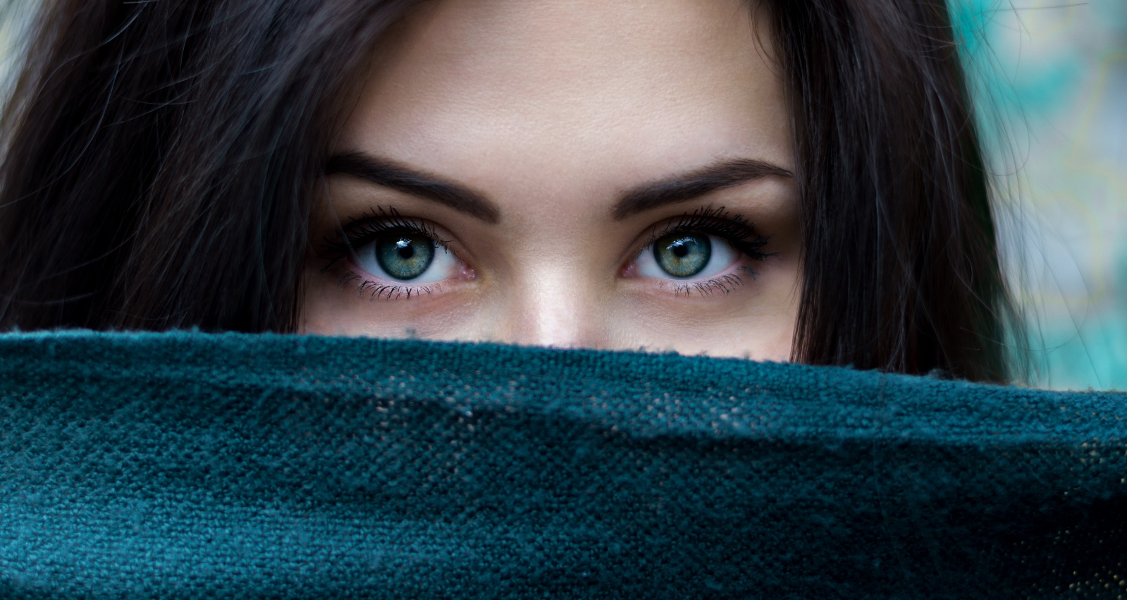

(SALON NAME) NEWS
YOUR LOGO
HERE


MONTHLY NEWSLETTER

SALON NAME
Address & Phone Number
www.website.com
Book a full set of acrylic nails for just $60
and you will also receive:
Feature nails valued at $10
Gel top coat valued at $7
Free mini pedicure valued at $35
Free sexy toe ring valued at $15
Homecare pack valued at $21
$20 waxing voucher
ALL FOR FREE!

Total value $168 you pay just $60,
SAVE $108 - First 13 clients to book will receive blab la bla.

Our Special
of the Month!

Whether your concern is lines and wrinkles, pigmentation, enlarged pores, congestion and blemishes or a generally tired, dull complexion, there are some simple skin-refining solutions that can offer fast relief.
Consider a peel. “Peels offer great benefit for a variety of conditions,” explains Dr Jo-Ann See from Sydney’s Eastern Suburbs Dermatology. “They can help clear acne, reverse photo ageing, soften lines and improve both the appearance and feel of the skin.”
(Salon name) is now offering a peel for those of you who have never tried it before for only $00.
Go on to do your offer:
Peel
Free massage before valued at $$$
All this for only $000!
Only available for the first 50 who call in, so what are you waiting for? Call 9999 9999 now.
Don’t forget ,we have a 100% money-back guarantee if you are not completely delighted!

Peel away the years: Our latest technique to radiant skin

ISSUE NO. 001



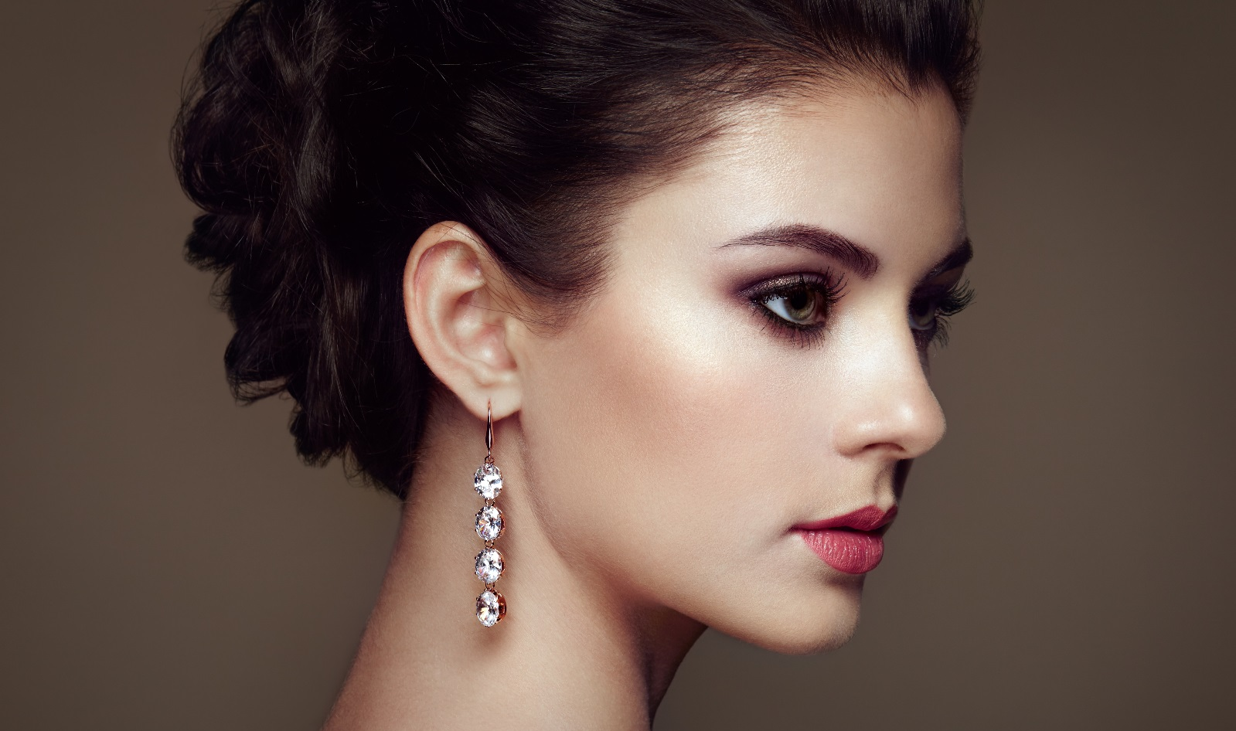
What is IPL?
We use intense pulse light (IPL) machines to treat a range of cosmetic conditions such as the removal of unwanted hair, improve skin tone and texture, and reduce age spots.
The IPL machine emits very small amplitude wavelength light through a crystal sapphire head. The light penetrates deep into the skin reaching all the way to the inner layer (known as the subcutaneous layer or hypodermis).
The colour of the structures (such as the red in veins, or pigmentation in hair or freckles) attracts and absorbs light of different wavelengths depending on the colour.
Our machines are specially designed to have a variety of settings depending on what we are targeting, providing a safe and specific way of reaching only the structures that are considered problematic.
Treatments take approximately 30-45 minutes. Patients can apply makeup before leaving the office and return to work the same day. There is also minimal pain with IPL, unlike laser or radiofrequency resurfacing which both require topical anesthetic. Also, with IPL, a larger area can be treated at one time than with laser treatment.

SALON NAME Address & Phone Number www.website.com
Lorem ipsum dolor sit amet, consectetur adipiscing elit. Vivamus congue purus eget luctus condimentum. Fusce aliquet risus non lacus finibus massa. Sed lectus magna, viverra sed lectus in, placerat vestibulum tellus.
In consectetur mi odio, a viverra massa porta non. Curabitur quis purus nec nunc ullamcorper dapibus finibus vel odio.
Birthdays

Other Announcements

Lorem ipsum dolor sit amet, consectetur adipiscing elit. Vivamus congue purus eget luctus condimentum. Fusce aliquet risus non lacus finibus massa. Sed lectus magna, viverra sed lectus in, placerat vestibulum tellus.
In consectetur mi odio, a viverra massa porta non. Curabitur quis purus nec nunc ullamcorper dapibus finibus vel odio.

MONTHLY NEWSLETTER

