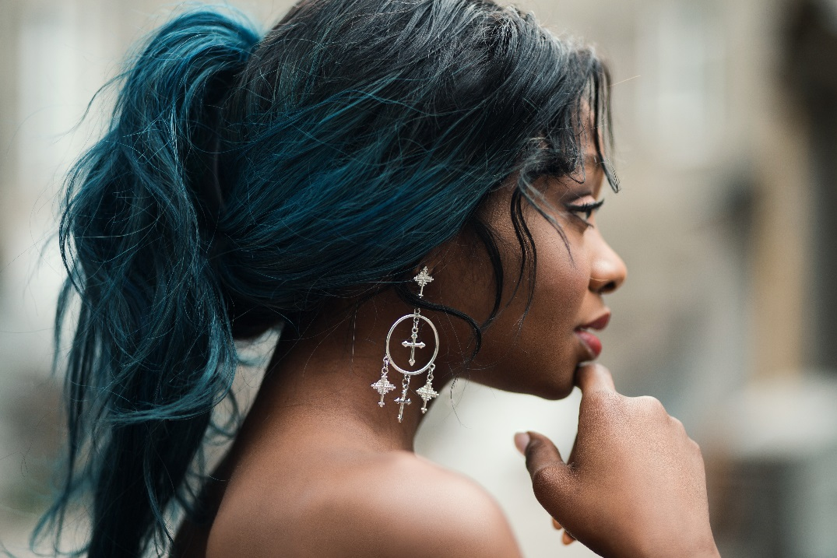
Salon Name News
(Salon Owner)’s Note

Do you know what I love about winter? Other than snuggling up on the couch and listening to the rain fall while you’re all tucked up in bed, winter also allows you to be a little slack in the shaving of your legs department.

It finally means you can give long-term hair removal a go. Hurrah! More text, more text.


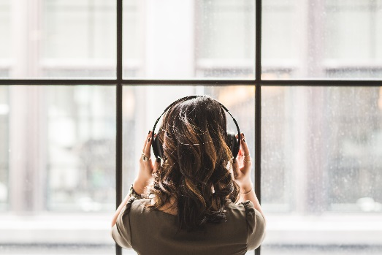
Peel away the years: Our latest technique to radiant skin
Whether your concern is lines and wrinkles, pigmentation, enlarged pores, congestion and blemishes or a generally tired, dull complexion, there are some simple skin-refining solutions that can offer fast relief.
Consider a peel. “Peels offer great benefit for a variety of conditions,” explains Dr Jo-Ann See from Sydney’s Eastern Suburbs Dermatology. “They can help clear acne, reverse photo ageing, soften lines and improve both the appearance and feel of the skin.”

Medical strength peels are the strongest and most effective. They generally require down-time, can be uncomfortable and must be administered by a dermatologist, cosmetic surgeon or cosmetic nurse, who will closely monitor activating time and pre-and post-peel care.
(Salon name) is now offering a peel for those of you who have never tried it before for only $00.

Peel Package Deal Here
Free massage before valued at $$$
All this for only $000!
Only available for the first 50 who call in, so what are you waiting for? Call 9999 9999 now.

Don’t forget ,we have a 100% money-back guarantee if you are not completely delighted!

5 Reasons
Why You Need A Facial

Insert text here Insert text here Insert text here
Insert text here Insert text here Insert text here Insert text here Insert text here Insert text here Insert text here Insert text here Insert text here
Insert text here Insert text here Insert text here
Insert text here Insert text here Insert text here Insert text here Insert text here Insert text here Insert text here Insert text here Insert text here Insert text here Insert text here Insert text here Insert text here Insert text here Insert text here Insert text here

So call us now, and we promise you’ll feel better!

Phone 000 000 000

SPECIAL OF THE MONTH

Book a full set of acrylic nails for just $60
and you will also receive:
- Feature nails valued at $10 FREE
- Gel top coat valued at $7 FREE
- Free mini pedicure valued at $35 FREE
- Homecare pack valued at $21 FREE
- $20 waxing voucher FREE
Total value $168 you pay just $60,
SAVE $108 - First 13 clients to book will receive blab la bla.


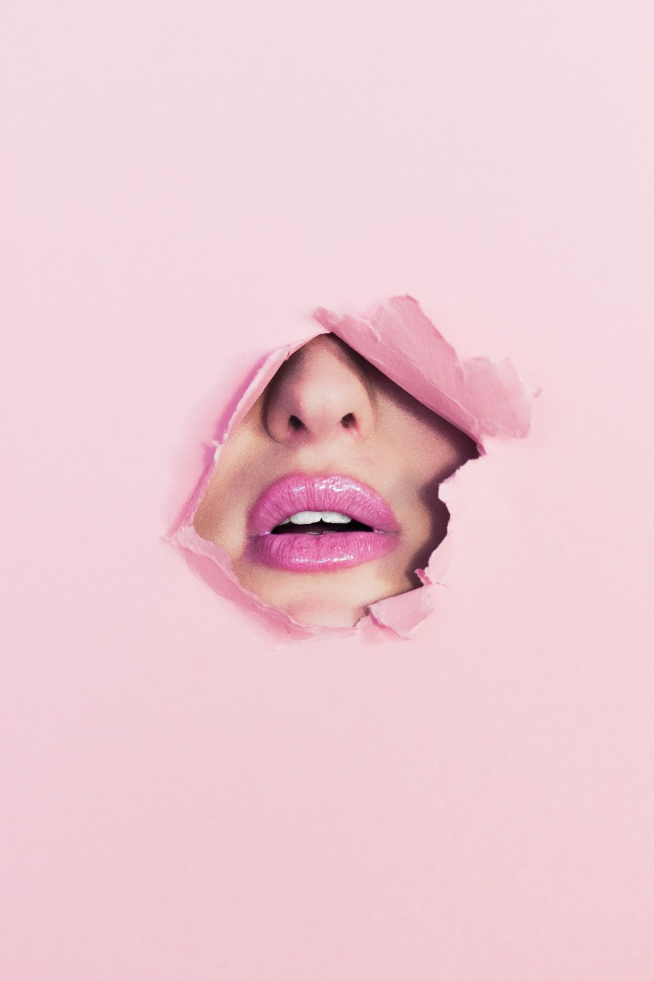
Salon Name
Address
Phone 000 000 000
www.website.com

Announcements
Insert text here Insert text here Insert text here Insert text here Insert text here Insert text here Insert text here Insert text here
Birthdays
Insert text here Insert text here Insert text here Insert text here Insert text here Insert text here Insert text here Insert text here
Peel away the years: Our latest technique to radiant skin
We use intense pulse light (IPL) machines to treat a range of cosmetic conditions such as the removal of unwanted hair, improve skin tone and texture, and reduce age spots.
The IPL machine emits very small amplitude wavelength light through a crystal sapphire head. The light penetrates deep into the skin reaching all the way to the inner layer (known as the subcutaneous layer or hypodermis).
The colour of the structures (such as the red in veins, or pigmentation in hair or freckles) attracts and absorbs light of different wavelengths depending on the colour.
Our machines are specially designed to have a variety of settings depending on what we are targeting, providing a safe and specific way of reaching only the structures that are considered problematic.
In other words, IPL does not damage the skin surface, unlike dermabrasion and laser resurfacing. Therefore, there is virtually no recovery time.”
Treatments take approximately 30-45 minutes. Patients can apply makeup before leaving the office and return to work the same day. There is also minimal pain with IPL, unlike laser or radiofrequency resurfacing which both require topical anesthetic. Also, with IPL, a larger area can be treated at one time than with laser treatment.

Mary’s getting married!

Our lovely therapist Mary is going to getting married…in Scotland!

She will not be in the salon for two weeks. Continue text Continue text Continue text Continue text Continue text Continue text Continue text Continue text Continue text

