
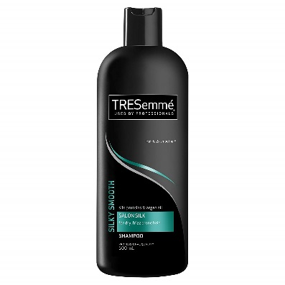

(Salon Name) is committed to providing clients with the most advanced hair care in the area. We strive to make your visit the best experience possible, and if you are not completely satisfied, we will either redo your hair for you for free, or give your money back, no questions asked.
Salon Name
Address
0000 000 000
www.website.com
A message from
(Salon Owner)

Product of

the month
You must have this rich hair mask! It gives your hair the softest feel, and banish dry and stubborn winter hair. $100.00

What is Balayage?
Balayage, a French word meaning ‘to sweep’ is a new method of highlighting which lightens the hair gradually from root to tip. This technique has shaken the salons from coast to coast because it achieves an ultra-natural effect by mimicking nature’s way of lightening hair. Hair should always be darker on the base of the hair shaft or the root area, rather then having light roots and dark ends.
The contrast of the deep, almost ashy brown set against those honey-blonde highlights really do amazing things for complexion as well as making hair look about 1000 times cooler than if hair was all the one colour.
To balayage the hair, a lightening agent is painted on using a brush and paddle in a sweeping motion giving the hair colourist a bit more room to play and less methodical streaks. Foils aren’t used and the precision of the fine-tooth comb weaving in tiny streaks is no longer necessary.
(Salon Name) is now offering balayage treatments for $$$, but if you bring this newsletter in, you pay only $$$, and we’ll also give you a tingling scalp massage for free!
Call 9999 9994 now to book your appointment, as we are only offering this special package for the first 10 callers.

Issue 001 2018

INSIDER
HAIR





Call NOW for an
appointment
000 000 000
Salon St
Suburb

Monthly Hair Tip:
Are you using the right shampoo?
Selecting the best shampoo for your hair is essential in order to maintain and achieve healthy and beautiful hair.

It‘s crucial to use a shampoo that is appropriate for your hair type, otherwise it won’t be effective enough. For example if your hair is oily you should never use shampoo or conditioner designed for dry hair, because it won’t remove the excess oil from your scalp and it can cause other hair problems such as dandruff, frizzy or even split ends.

Appointment Etiquette:
Please let us know if you need to cancel within 24 hours. If less than that, you will lose your deposit, as we would not be able to book another person in your spot.
Announcements:
Mary has left our salon to pursue her dreams of becoming an actress. We wish her all the best!

OFFER
OF
THE
MONTH
OfferOfferOfferOffer
Only 13 packages available so hurry up and call
9999 9999 now
Remember, if you are not completely delighted,
we will redo it for free, or refund your money.

