HAIR & BEAUTY NEWS FOR THE MODERN WOMAN
An Open Letter to (Your Town) Women Who Want to Have Perfect Hair Every Day - But Don't Know How.
New study reveals why 60% of women lack the knowledge to understand how to select and use the correct styling products.

Bundaberg, Tuesday. By Bonnie McIntosh, Grooming Consultant
Frustrated by what you see in the mirror as you prepare for your day every morning? Don't worry, you're far from alone. Millions of women feel exactly the same.
A new study by giant multinational Proctor & Gamble has revealed that getting their hair right is overwhelmingly the most important part of a woman's morning routine and can affect her for the entire day. Over 90% of women questioned in the study claim that their hair is crucial, more crucial than choosing the right clothes. Yet over 70% of women ad dissatisfied with the way their hair looks and feels at least once a week, and most of these women do not achieve the look they want almost half the time due to incorrect self-diagnosis.
With most women making their hair product buying decisions based on what they see in TV commercials, it's little wonder the P & G study finds that fully 51% of consumers are frustrated trying to find the right product for their hair type.
According to Louise Scott, Director of Research and Development at P&G, 'Broadly appealing benefits such as shine, nourishing, healthy, revitalizing, control and moisturizing cannot be used as descriptor aids because they confuse the consumer, which may lead to using the wrong product.'
Getting it right
In a significant finding, the research showed that half of all women have misdiagnosed their hair type; in other words, 50% of women are using the wrong type of shampoo and conditioner, leading to a variety of conditions such as loss of potential volume, lack of shine, and hair feeling unmanageable.
Your picture here

Your 100% Guarantee:
"In the unlikely event you're even slightly unhappy with your hair, just say so within 7 days and we'll re-do it, FREE!"
A Special Offer from (Your Name), owner of (Your Salon):
"FREE Hair Analysis and Home Treatment Program valued at $65 - PLUS a Free Sample You Can Take Home and Test, valued at $20 - when you book your first appointment!"
But you MUST be among the first 17 to call NOW
Ph 000 000 000
Your Salon, address etc

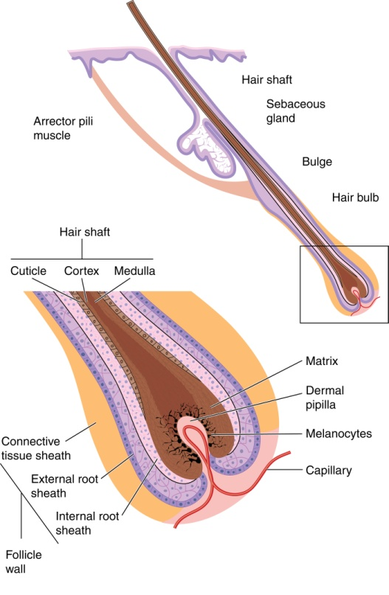
Fortunately, a solution is close at hand for women in (your suburb/town)
Anatomy of human hair
Staff at (Your Salon) have been trained extensively to recognise and diagnose individual hair types, and recommend not only the right style, but exactly the right hair care products for your particular hair type.
According to salon owner (Your Name), "The P&G study backs up what we've suspected for years, that one size definitely does not fit all."
Human hair is a complex organ, with every person having slight differences in structure, composition, texture and resilience, requiring precise diagnosis to achieve the best possible results.
"At (Your Salon), we actually insist with every new client that we spend time assessing hair type and condition before we recommend any products or styles. That way you're guaranteed that you leave the salon with the 'perfect match' of style and product to ensure you can always enjoy that 'just done in the salon' look." (Your salon) is offering specialised analysis and prescriptive treatment so that every (your town) woman can achieve perfect results, every time - and never need again need to feel frustrated about their hair.

