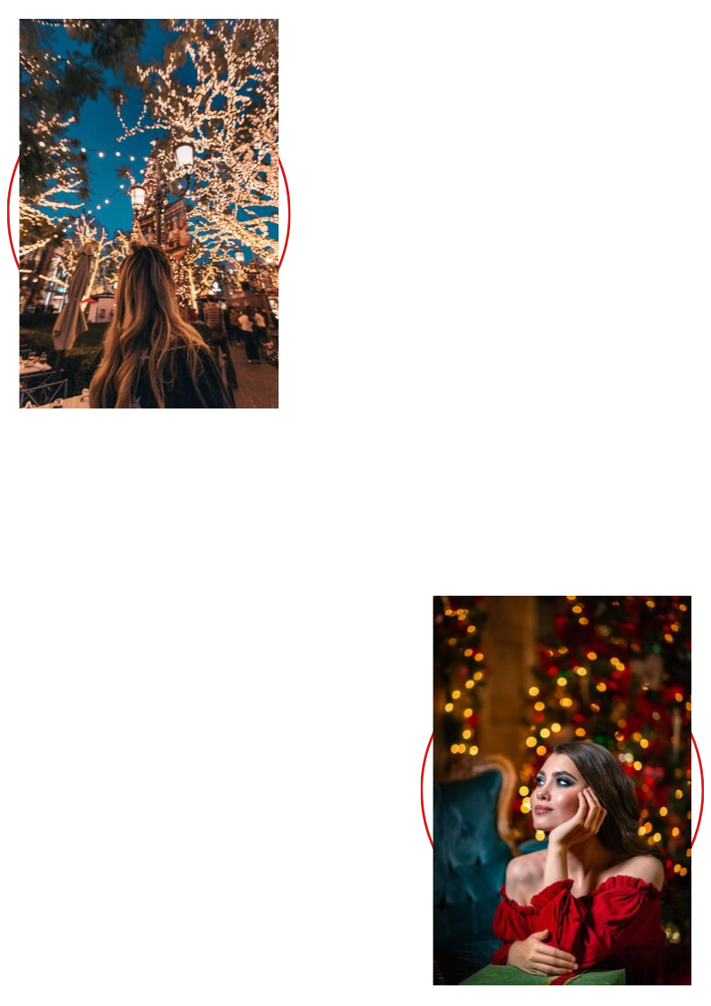
VALUED AT $242
Just $109
Our Guarantee:
We’re so confident in our services that we offer a 100% money-back guarantee! If you don’t feel like a goddess after your treatment, we’ll refund your money in full.
No exceptions!
What do our clients think?
“I absolutely love {Salon Name},
It’s the best salon I have ever been to!”
- {Client Name}, {Occupation}
The Jaw Dropping Hairstyle Package
MAKE THE FAMILY ENVIOUS!
CALL 0000 00 0000

HURRY ONLY 17 AVAILABLE!

This Package includes:
- Expert Style Cut, valued at $89
- 10 highlighting foils, valued at $60
- Moisturizing Hair Treatment, valued at $27
- Styling Lesson, valued at $46
- PLUS, a $20 VOUCHER to use
- at our salon with your next visit!

DON’T FORGET THE OTHER
MEANING OF CHRISTMAS…

