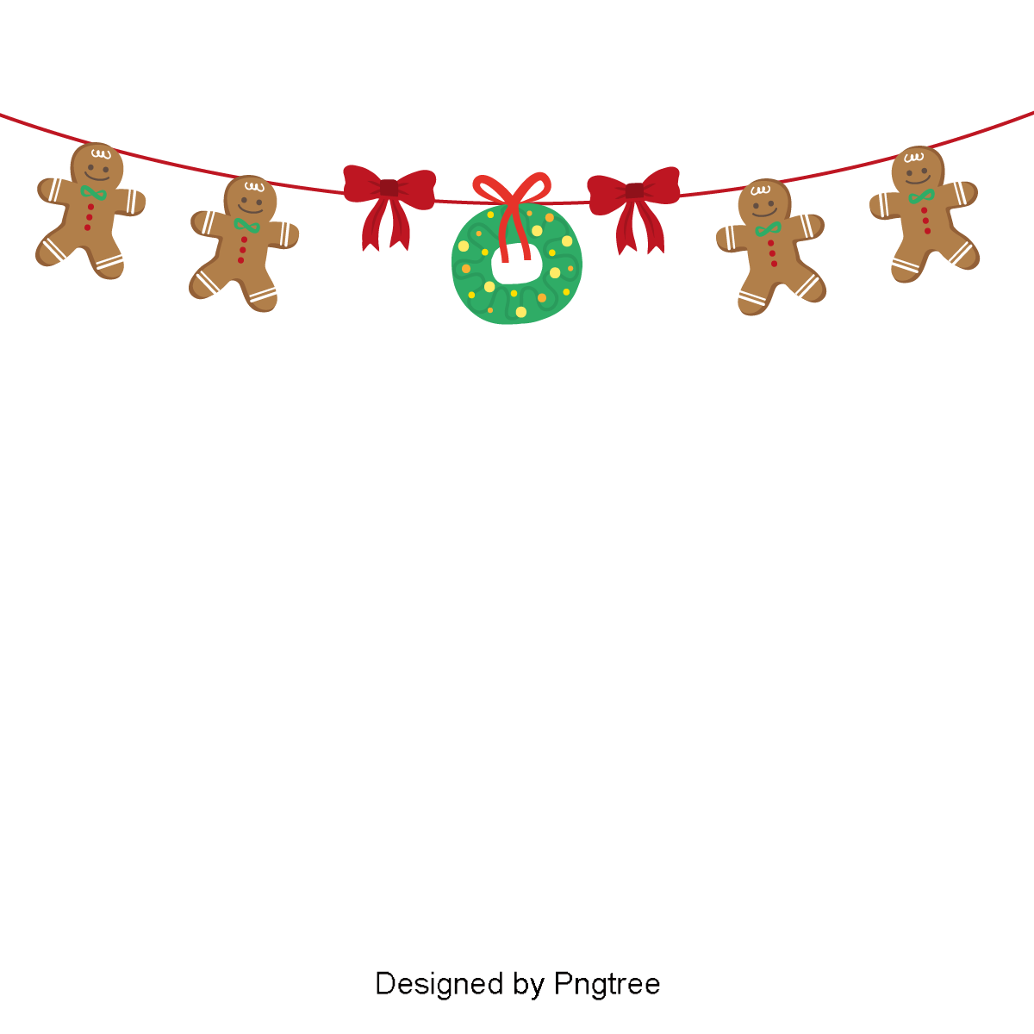

Book and pay for your next service in January and you get to choose a Lucky Dip prize from our Christmas Tree.
Every box contains a Gift Voucher - and one of them is worth $300!

Have you taken a chance with our Christmas Tree Lucky Dip?

