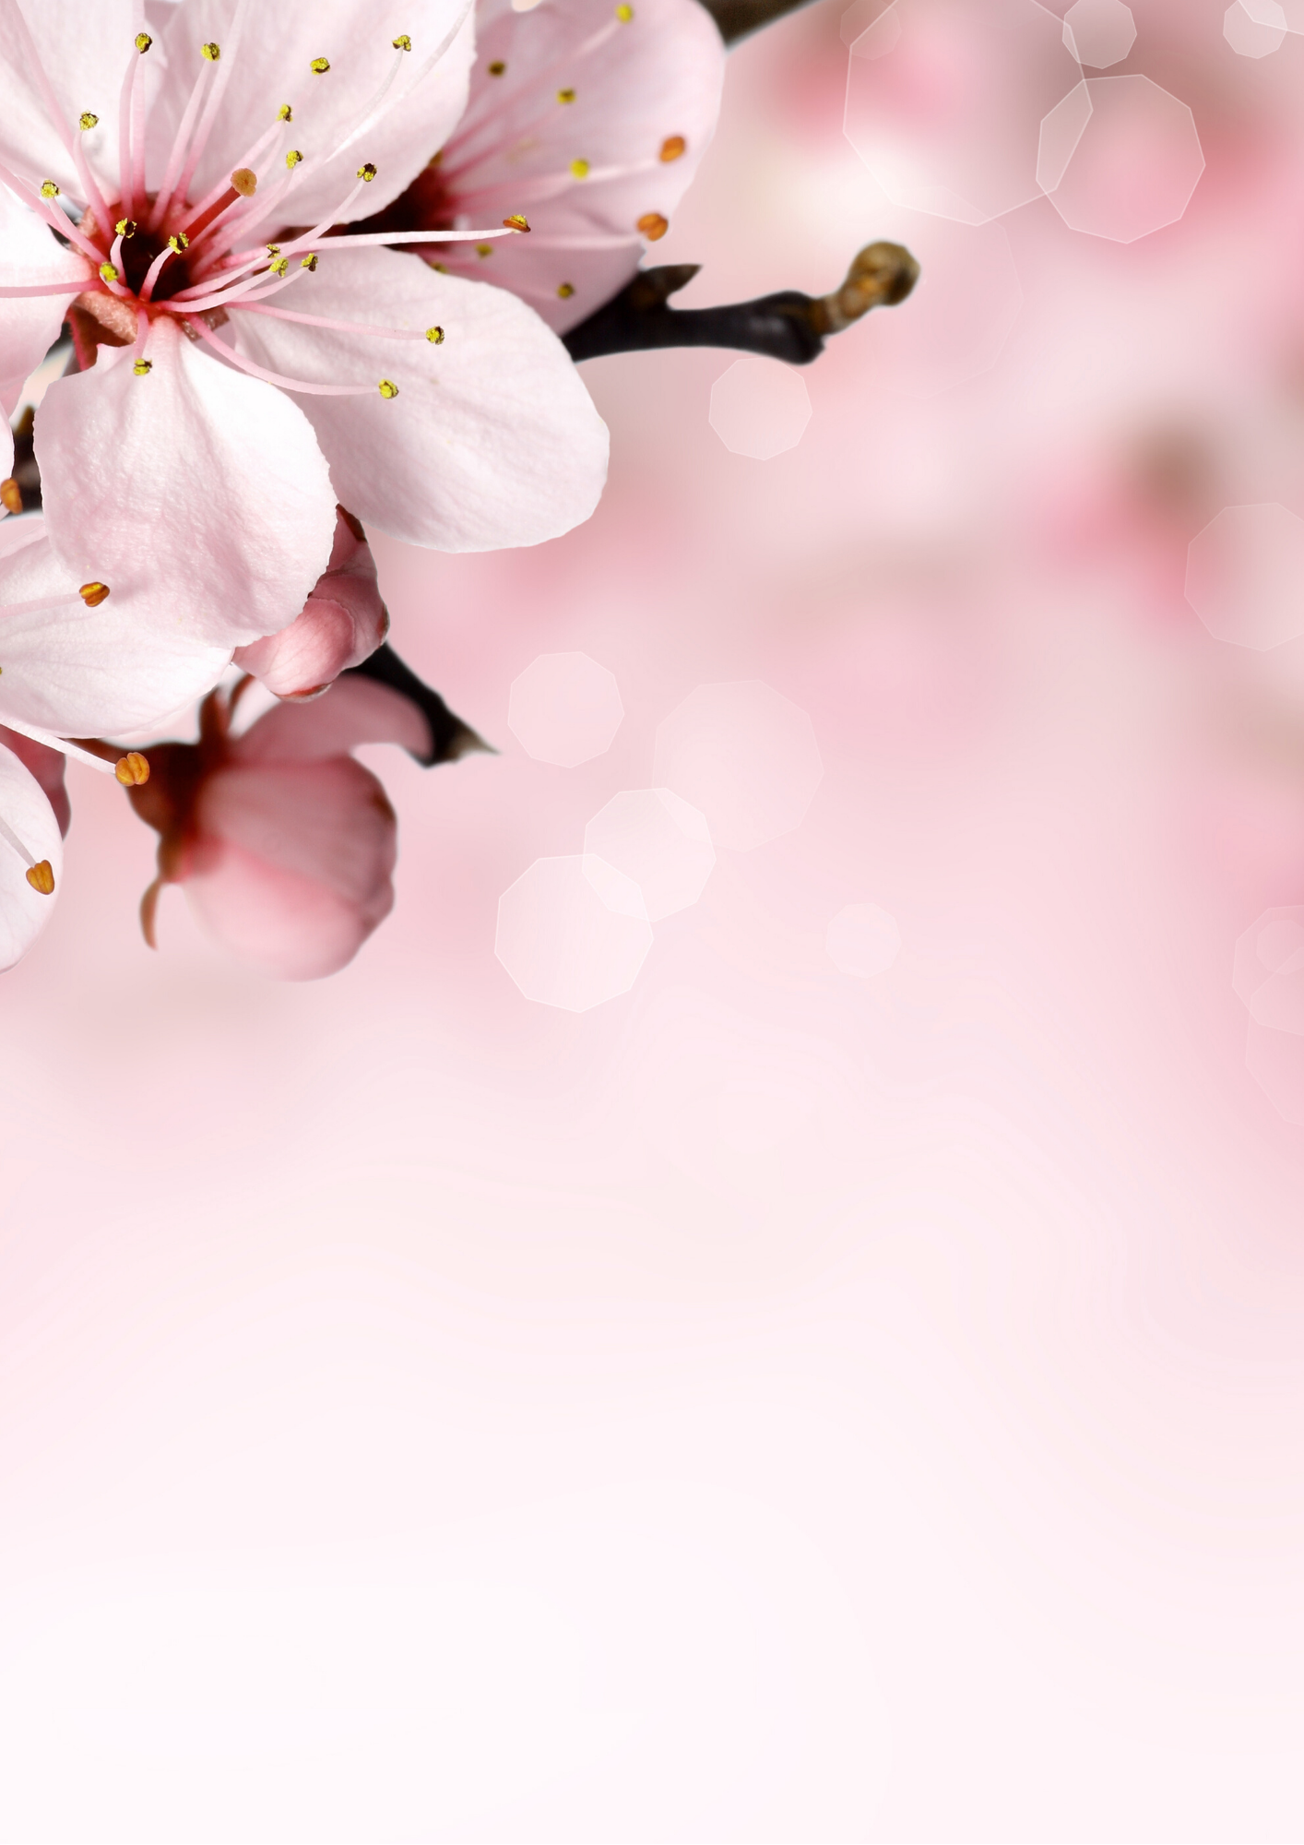
We’re still here for you
Come escape and relax. Be assured we’re doing everything required (and more!) to keep the germs at bay. So, come on in and enjoy!

