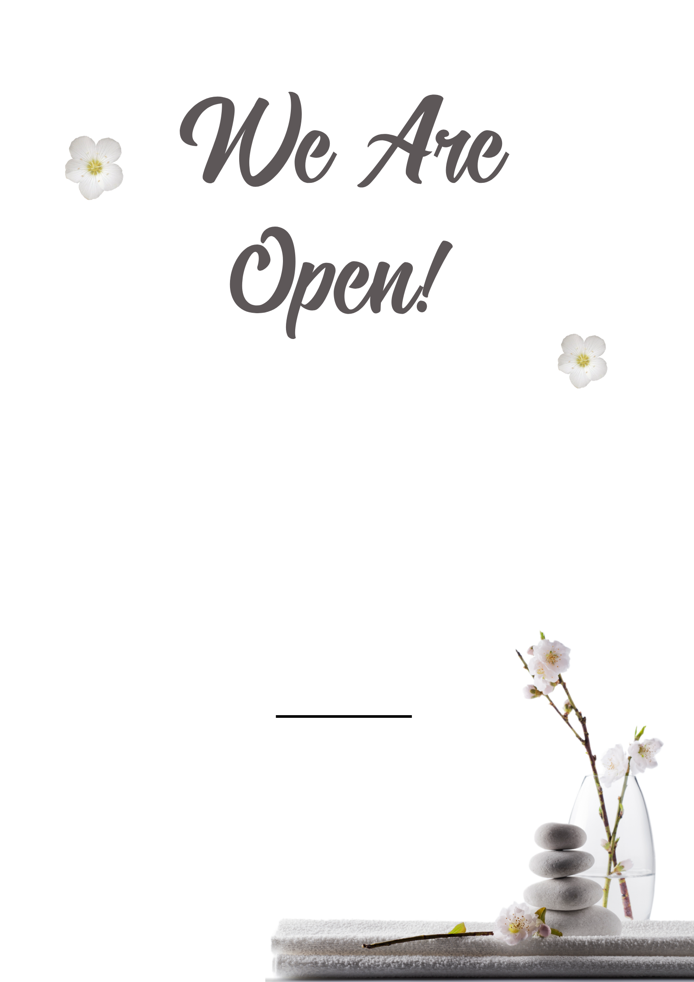
See in store for our re-opening special offers.
Looking after the health and well-being of our clients with rigorous hygiene and social distancing practices.

